**MATLAB Project: Single Cell Wing Bending, Torsion, and Shear Analysis**

**Work Update:**

So far I have gone through all the materials and urging to find an optimize solution to achieve the tasks target. I firstly tried to understand the excel files and then I thought it will be better if I design the wing myself. So I wrote a code which displays a single cell wing in a 3d structure. The code and output is demonstrated below:

**Code:**

clear all; clc

%RECTANGULAR WINGS

c = 1;

s = 5;

nCS = 10;

profile = readmatrix("wing.txt");

profile = [profile; profile(1,:)];

nNodes = size(profile, 1);

x = profile(:, 1)';

y = profile(:, 2)';

%plot(x, y)

% axis equal

z = linspace(0, s, nCS);

X = repmat(x, nCS, 1);

Y = repmat(y, nCS, 1);

Z = repmat(z', 1, nNodes);

X = [0.5*c*ones(1, nNodes); X; 0.5*c*ones(1, nNodes)];

Y = [zeros(1, nNodes); Y; zeros(1, nNodes)];

Z = [zeros(1, nNodes); Z; s*ones(1, nNodes)];

surf(Z, X, Y)

axis equal  
**Output:**

**2D – Single Cell Wing Display**

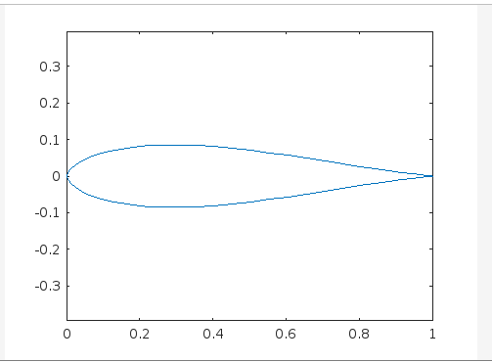

**3D – Single Cell Wing Display**

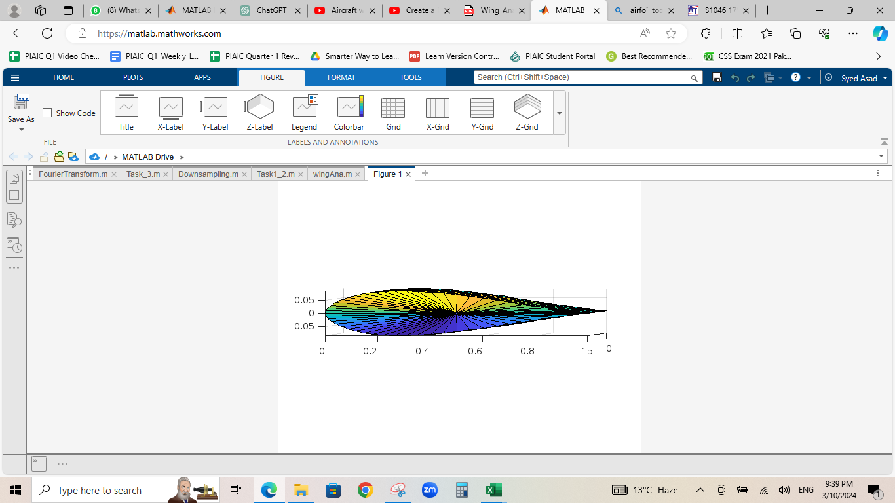

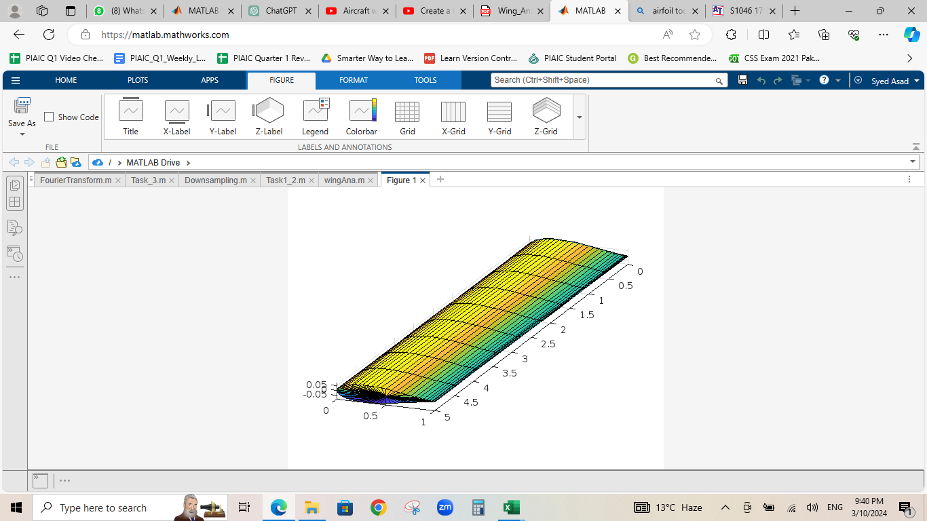

**ALSO USED:**

A text file named as wing.txt which contains the wing dimensions. These dimensions are given below:

**x-palne y-plane**

1.00000 0.00000

0.99616 0.00022

0.98513 0.00134

0.96778 0.00347

0.94451 0.00634

0.91556 0.01001

0.88146 0.01459

0.84282 0.02007

0.80030 0.02639

0.75460 0.03341

0.70644 0.04097

0.65656 0.04882

0.60571 0.05665

0.55447 0.06395

0.50324 0.07044

0.45251 0.07597

0.40277 0.08035

0.35450 0.08339

0.30811 0.08495

0.26398 0.08492

0.22247 0.08324

0.18385 0.07984

0.14834 0.07476

0.11614 0.06815

0.08745 0.06017

0.06246 0.05106

0.04136 0.04107

0.02431 0.03052

0.01149 0.01974

0.00306 0.00925

0.00000 0.00000

0.00306 -0.00925

0.01149 -0.01974

0.02431 -0.03052

0.04136 -0.04107

0.06246 -0.05106

0.08745 -0.06017

0.11614 -0.06815

0.14834 -0.07476

0.18385 -0.07984

0.22247 -0.08324

0.26398 -0.08492

0.30811 -0.08495

0.35450 -0.08339

0.40277 -0.08035

0.45251 -0.07597

0.50324 -0.07044

0.55447 -0.06395

0.60571 -0.05665

0.65656 -0.04882

0.70644 -0.04097

0.75460 -0.03341

0.80030 -0.02639

0.84282 -0.02007

0.88146 -0.01459

0.91556 -0.01001

0.94451 -0.00634

0.96778 -0.00347

0.98513 -0.00134

0.99616 -0.00022

1.00000 0.00000

**EXPLANATION:**

I used this approach of designing the wing first so I can customize the wing’s width, height, length and curves accordingly so then I can move towards the requirement of the code and all the required functionalities will be handled through the structural design of wing dynamically and no manual entries of values will be required.  
This is my proposed agenda to achieve the required output of the task. It may work accordingly and it may require to change some methodologies accordingly as we pursue our target.   
It is the initial agenda plan of what I am trying to do. If this is implemented successfully then it will be the most optimize approach towards our goal that is the project requirement.